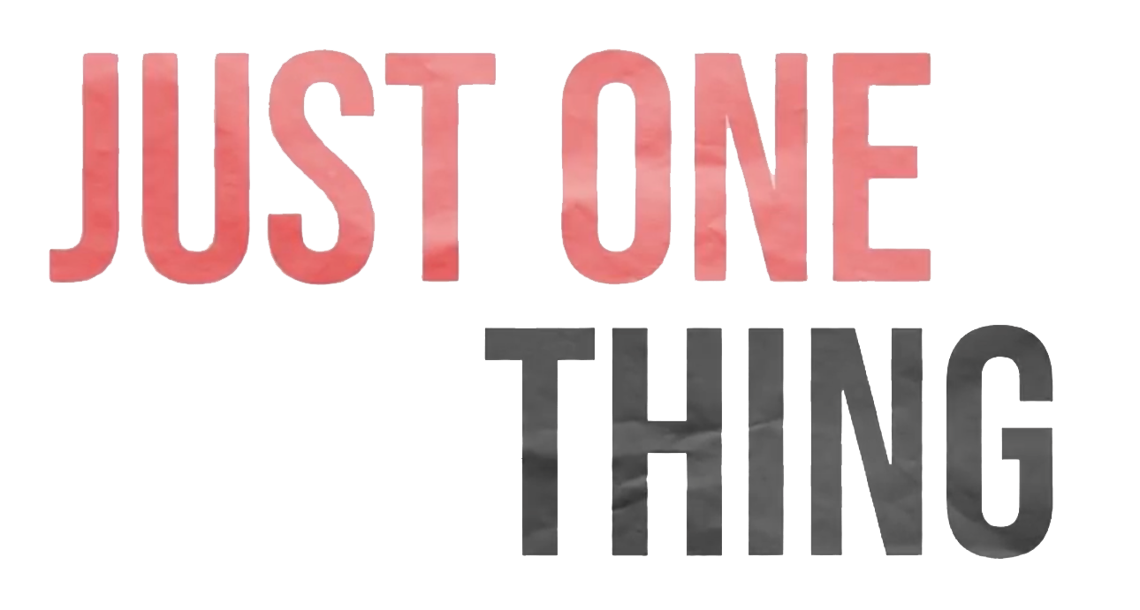

|  |
| --- |
| **Before Class Prep |** |

**Cue up videos, or have students watch a Just One Thing episode (or a few). By watching a few videos in the series students will have the opportunity to see different ideas and approaches to J1T production.**

**Part of the philosophy of Just One Thing’s production was flexibility with creators. In keeping with this, we suggest allowing students to either come with an idea or brainstorm in a group.**

|  |
| --- |
| **Video Discussion** |
| **Introduction & Discussion |** |

* **Discuss both the method and content of the video(s)**
  + What visuals stuck out to you and why? Do you think this is what the producers intended?
  + What do you think was important for the creators?

|  |
| --- |
| **Your Just One Thing** |
| **What is important to you?** |

* Why is this important for you?
* Why is this important for others to hear about?

|  |
| --- |
| **How are you going to say it?** |

* What format would you like to utilize?
* What feeling or tone would you like to work towards?
* Where, when, and why?
  + *Pick who you want to talk to? Why?*
  + *Where you will go?*
  + *Who will be your main narrator?*
  + *What are the most interesting points of your topic?*
  + *Who is your audience?*
  + *What information/exposition do you need to tell your audience?*

|  |
| --- |
| **| Visuals** |

What visuals do you have in mind that will assist in communicating your idea?

|  |  |  |  |
| --- | --- | --- | --- |
| Visual idea description  (draw or write what a moment in you would like to convey in your Just One Thing video) | Source ideas  (try to find a similar depiction of what you have in mind) | Medium  (still image, text, animation, moving image ect.) | Make a plan B of a second way you can present your visual |
|  |  |  |  |
|  |  |  |  |
|  |  |  |  |
|  |  |  |  |

|  |
| --- |
| **Representation and Depiction |** |

How would you represent your Just One Thing on different platforms? What would be the possibilities and constraints that each setting would offer?

|  |  |  |
| --- | --- | --- |
| Platform | Possibilities | Constraints |
| With a friend through conversation |  |  |
| YouTube |  |  |
| Twitter |  |  |
| Instagram |  |  |
| TikTok |  |  |
|  |  |  |
|  |  |  |

Notes: