Direct-manipulation animation: incorporating the haptic channel in the learning process to support middle school students in science learning and mental model acquisition

Margaret S. Chan John B. Black
Department of Human Development
Teachers College, Columbia University
New York, U.S.A.
chan@tc.columbia.edu, black@tc.columbia.edu

Abstract
The study reported here investigated what learners need to construct and master mental models of systems. To enable learners to perform the cognitive processing needed to understand structure, purposes, and functional relations among system entities, we developed a special form of animation: Direct-manipulation animation. Furthermore, we propose a cognitive processing model that elucidates the process of learning with information presented through auditory, visual, and haptic channels. We conducted an empirical study with 157 seventh-grade public school students, whom we asked to learn about mechanical energy transfer with narrative-only, narrative-and-static-visuals, or narrative-and-animation. The effect of content complexity on learning with different presentation formats was also examined. Our findings suggest that direct-manipulation animation, incorporating the haptic channel in the learning process, provided learners with proper learning experiences to reason about structural causal interactions and functional relations in systems facilitated acquisition of mental models of systems.

Introduction and research objectives
How can we help students develop mental models of systems and scientific phenomena? Systems—simple or complex, open or closed, visible or invisible—are pervasive in the world around us. Developing students’ understanding of systems is a major theme spotlighted in the National Science Education Standards (National Research Council, 1996). The American Association for the Advancement of Science has also identified “systems thinking” as one of four major themes in science education (AAAS, 1993). Although comprehending how systems work is critical to science learning, considerable research has shown that understanding systems, especially complex ones, is notoriously difficult for students of all ages (Chi, 2000; Feltovich et al., 1992; Hmelo, Holton & Kolodner, 2000; Jacobson, 2000).

Mental model acquisition is at the heart of meaningful learning (Black, 1992; Gentner & Stevens, 1983; Mayer, 2001). To comprehend and reason about how systems work, an individual needs to construct a mental model of these systems (White, 1993; Wilensky & Resnick, 1999). We argue that constructing mental models of systems entails understanding structural causal interactions as well as functional relationships among entities in systems. Specifically, structural causal interactions reveal how one entity is causally related to another (i.e., similar to causal chains in events or stories); functional relationships describe how a change in one parameter leads to a change in another parameter or the entire system (i.e., similar to a math function). Furthermore, we proposed a Structure-Purpose-and-Conceptual Ecology (SPACE) framework for comprehending dynamic systems (Chan & Black, 2005). The SPACE framework contends that understanding structure, purposes, and interactions among the components of systems is pivotal to system comprehension. For example, to understand how a roller coaster works, one needs to understand the topology and configuration of the coaster tracks, the roller coaster car design (structure); how mechanical energy converts in the various components of the ride (e.g., first hill, vertical drop, loop-the-loop, and 270-degree spiral, etc.) to propel the coaster cars and make the thrill ride fun (purposes of each components); and the interrelationships among various components of the entire system (conceptual ecology, a holistic perspective). These runnable mental models, in turn, afford individuals explanatory and predictive power to understanding simple and complex systems (Schwartz & Black, 1996). However, most classroom instruction tends to emphasize the acquisition (or memorization) of entities and structure over the more crucial understanding of causal interactions and functional relationships among system entities. Thus, the overall goal of our research is to investigate what kinds of learning materials and experiences are needed for learners, especially novices, to construct and master mental models of systems.

Systems can be conveyed by different formats; they can be described in text, illustrated by pictures/visuals, and depicted through animation. Each type of presentation format — narratives, pictures/visuals, and animation — has its own strength in communicating conceptual information. Previous studies have demonstrated that media research comparing students’ learning outcomes from one medium to another has been largely futile (Clark, 1994). Adopting a learner-centered approach, we are interested in investigating which presentation formats (narratives, static visuals, or dynamic animation) may best support learners in their efforts to understand systems and to construct mental models to reason about systems. Furthermore, we propose a cognitive processing model of learning that elucidates the process of learning with information presented in auditory, visual, and haptic channels.

Theoretical framework
Written description has long been widely used to convey system structures, operations, and interactions. Extensive research has demonstrated that readers can construct mental representations of the systems, devices, and situations described in a text (Garnham & Oakhill, 1996; Graesser, Singer, & Trabasso, 1994; Kintsch, 1998) and that they can draw inferences from the internal representations about those situations and systems (Black, Turner, & Bower, 1979; Bransford et al., 1972; Mani & Johnson-Laird, 1982). Although the printed word is the most prevalent format in education, considerable research evidence suggests that individuals’ understanding can be enhanced by the addition of visuals (i.e., pictures, illustrations, and so on) (Larkin & Simon, 1987; Mayer & Gallini, 1990; Tversky, 1995).
With the current trend to integrate multimedia and computers into school curricula, the use of animation to illustrate dynamic systems and phenomena in science and other subjects is increasingly commonplace. One advantage of animation over narratives and static visuals is its ability to represent change in time and to present information about change over time (Rieber, 1990). A pervasive assumption is that animation is a promising educational tool. Nevertheless, for decades, research comparing the effectiveness of text-and-static illustrations with animation-and-narration to enhance learning has been inconclusive (Mayer & Anderson, 1991; Pane et al., 1996; Rieber, 1989, 1990). Interestingly, Tversky et al. (2002) pointed out that while some studies found that animation appeared superior to static visuals in enhancing learning and transfer, a careful examination of these studies revealed a lack of equivalence between animated and static graphics in content as well as differences in experimental procedures.
In addition to methodological complications and information nonequivalence, we argue that the failure to ascertain the benefits of animation in learning may also relate to the way it is perceived and constructed. According to the apprehension principle for effective graphics (Tversky et al., 2002), “the structure and content of the external representation should be readily and accurately perceived and comprehended.” Although animation increases perceptually available information, explicitly showing the information does not necessarily guarantee that viewers will accurately perceive the specific information. Neither does their perception of information promise adequate comprehension and mental model construction. As Mayer (2001) asserted, meaningful multimedia learning requires learners’ active processing of the instructional material; merely showing animation to learners may not be sufficient to aid their learning. We believe a good match between presentation format (text, static graphics, and animation) and what learners need to construct a conceptual understanding of the systems will promote comprehension and learning (a Format-Support Hypothesis, Chan & Black, 2005).
Furthermore, Sweller and colleagues (1996) pointed out that if the content is complex (high intrinsic cognitive load) and a high level of interactivity among the entities is depicted in instructional materials (static and dynamic), the learners’ extraneous cognitive load may be overloaded; consequently, they may have difficulty perceiving and understanding the learning content. To overcome or mitigate the perceptual and cognitive demands that animation imposes on learners, we developed a special form of instructional animation, which we call direct-manipulation animation (DMA). Specifically, DMA allows learners to directly interact with navigation controls (i.e., buttons and sliders), freely determine their viewing direction, pace their navigation of the content, and visualize how change in one parameter affects other parameters in the system (Chan & Black, 2005). We hoped that DMA, being the closest match to the functional relations, enables learners to perform the cognitive processing needed to visualize and reason about the causal interactions and functional relationships among entities in systems (i.e., the constructivist nature of understanding).
A cognitive processing model of multimedia learning
We propose a cognitive processing model of multimedia learning that is based on a theoretical framework that draws on constructivism, working memory research, and cognitive load theory (Figure 1). According to the constructivist approach, learning is an active process in which students seek to make sense out of the to-be-learned information (Bruner, 1996). Meaningful learning occurs when learners engage in active cognitive processing. Information to be learned must be first processed through working memory (Baddeley, 1992). Research has consistently demonstrated that the limited capacity of working memory and the interaction between working memory and long term memory play a significant role in learning (Baddeley, 1998; Simon, 1974; Sweller et al., 1998). According to cognitive load theory, three sources of cognitive load (intrinsic, extraneous, and germane) can be imposed on individuals in learning. Specifically, the load of working memory is affected by the level of complexity of the subject content (intrinsic cognitive load) and the strategies for information presentation (extraneous or germane load). Optimum learning can occur when intrinsic load is considered, extraneous load is kept to a minimum while germane load is maximized by the design and implementation of activities and representations, thereby facilitating schemata change in long-term memory.

In our proposed cognitive processing model of learning, information may enter a learner’s systems via three channels: auditory, visual, and haptic. In a technology-supported learning environment, information may be presented in spoken words, which enter through the ears (auditory-hearing); the learner may select relevant sound input and move the information to the Verbal Articulatory Loop (Baddeley, 1992) for further processing in working memory. Similarly, the external representations may be visual (i.e., written words, pictures, and animation), which enter through the eyes (visual-vision); the learner may attend to pertinent incoming images and transfer the information to the Visual/Spatial Sketchpad (Baddeley, 1992) for further processing. Furthermore, external representations may involve the haptic channel (e.g., direct-manipulation animations), entering via the sense of touch through the hands; the learner may decide on and/or interact with relevant motions in the Kinematics/Tactile Displays (Meyer & Kieras, 1997). To summarize, the working memory is composed of different sections for visual (Visual/Spatial Sketchpad), auditory (Verbal Articulatory Loop), and haptic (Kinematics/Tactile Displays) information, together with a Central Executive (Baddeley, 1992) that controls the functioning of working memory and its interaction with the long-term memory (LTM). Ideally when processing, the 3 different types of information (i.e., words, pictures, and movement) are integrated to form a stronger representation than any one by itself.
Interestingly, our interactions with information coming in through the haptic channel are different from our interactions with information entering the visual and auditory channels. Specifically, when incorporating the haptic channel in the learning process, learners not only can visualize the information but also interact with it through their hand controls. The immediate sensorimotor feedback they received from their hand motions can be transferred to working memory for further processing. A benefit of learning with kinematics displays is that it enables learners to actively engage and participate in the meaning-making journey. It is a two-way communication process, with learners controlling the pace, speed, direction, and magnitude of the exploration.
Figure 1. A cognitive processing model of multimedia learning.
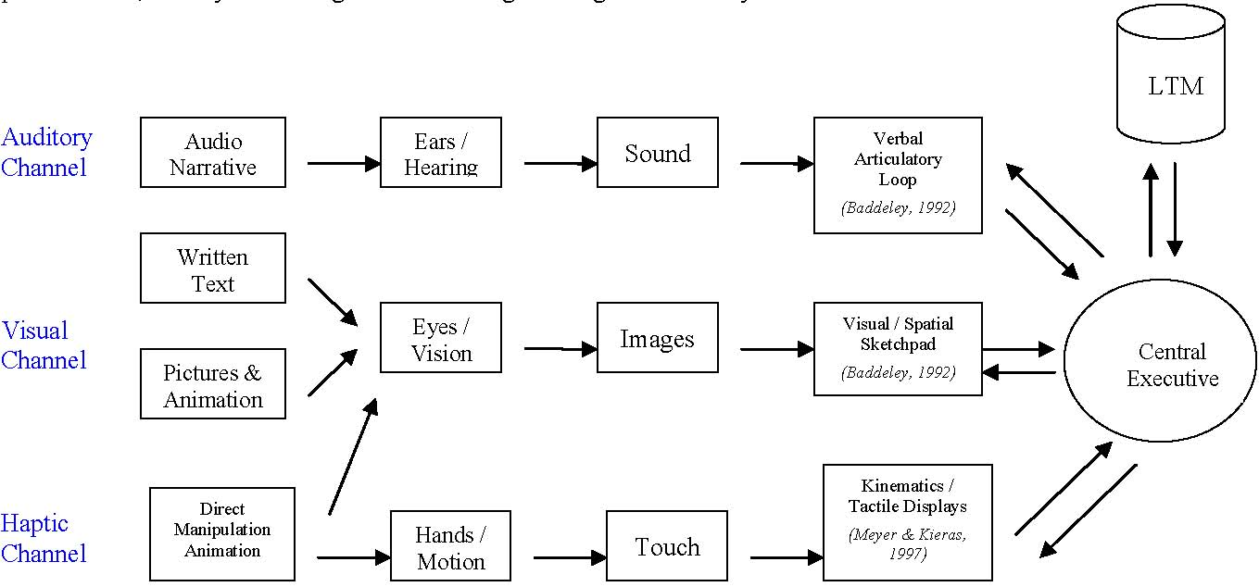
Research Questions
The principal research question for the study focuses on what learners, especially novices, need to understand systems and construct mental models to reason about the structure, purposes, and functional relations of systems. Since systems can be conveyed in different formats (text, pictures/visuals, and animation), we are interested in examining which presentation formats may best foster system understanding and mental model acquisition. An additional research focus of our work is to investigate the role of content complexity (i.e., simple, moderate, and complex) in learning with the three presentation formats. Do learners need different presentation formats to understand content at different levels of complexity?

Method and Data Source
To answer these research questions, we compared the learning and affective outcomes of middle school students who were asked to learn about Newtonian mechanics with narrative-only, narrative-and-static-visuals, and narrative-and-animation. Energy, a fundamental concept in physical science, is a major topic in the science standards and middle school science curricula. Although energy is everywhere, its workings are abstract. Students are often confused about energy-force and energy-motion relationships and have difficulty understanding the laws of conservation (George et al., 2000; Grimellini-Tomasini et al., 1993). Because of the conceptual complexity and invisible nature of the energy transfer process, we chose energy conversion and the law of conservation of energy as the topic for this study. Students were asked to learn about mechanical energy conversion and the law of conservation of energy in one of three scenarios: a playground swing, a roller coaster ride, and pole-vaulting. For example, Figure 2 gives a screen shot of the computer simulation for the roller coaster scenario. Students in each scenario were further divided into three presentation format groups: a narrative-only group (N), a narrative-and-static-visuals group (V), and a narrative-and-animation group (A).

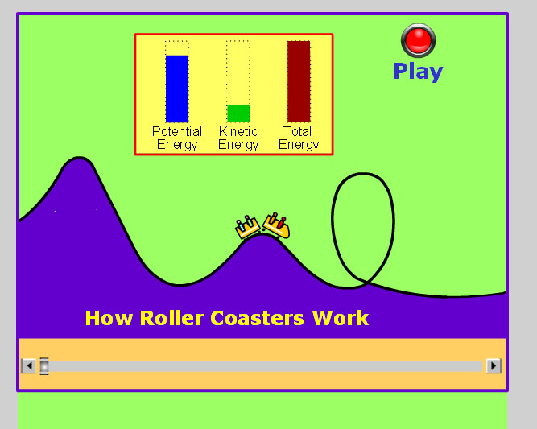

Figure 2. Screen shot of the direct-manipulation animation for Roller Coaster

We conducted an empirical study with 157 students (89 females and 68 males) from six seventh-grade science classes in an inner-city public school in New York. The mean age of the participants was 13.8 (SD=1.24). The student population consisted of the following diverse ethnicities: 34% Caucasian Americans, 35% Hispanic Americans, 26% African Americans, and 5% Asian Americans. All students were given parental consent forms, and only those with returned signed consents were allowed to participate in the study. All participants were tested during the same week of classes. Each participant was randomly assigned to a treatment group (N, V or A) and tested individually in one session lasting approximately an hour and fifteen minutes.

We used the following measures of learning: (1) a pretest on students’ understanding of the theoretical concepts and the interrelationships among the key entities; (2) a retention test, in which students were asked to write a summary explaining how mechanical energy works and to draw a diagram to illustrate the process of energy conversion according to their assigned content scenarios; (3) a “what-if” test, in which students were engaged in thought experiments to explain and predict the outcomes of scenarios in which the values of key parameters had changed; (4) a near-transfer task, in which students were asked to apply the concepts presented in the learning materials to two problem-solving tasks; and (5) a far-transfer task, in which students were asked to apply the learned concepts to a novel scenario. In addition, given our interest in students’ affective reaction to the treatment conditions, we asked them to fill out surveys about their learning experience with the presentation formats.

Results
Three graduate students (double-blinded) rated the results independently, and an inter-rater reliability score of .883 was achieved. A MANOVA was conducted to determine whether the groups (Narrative, Static-Visuals and Animation) with three content levels (simple, moderate, complicated) differed on retention scores, model-based reasoning, and transfer, and whether there was an interaction between presentation formats and content complexity (i.e., the two between-subject factors). The interaction was significant, Wilk’s Λ =.762, F(3, 147) = 1.692, p =. 022, multivariate η² = .066. This indicated that by using different presentation formats, participants’ comprehension and transfer performance differed as the content became complicated. The main effect for presentation formats was significant, Wilk’s Λ = .286, F(3, 147) = 20.695, p = .000, multivariate η² = .465. This suggested that participants’ learning outcomes differed depending on which group they were in: narrative-only, narrative-and-static-visuals, and narrative-and-animation groups. The main effect for content complexity was also significant, Wilk’s Λ = .630, F (3, 147) = 6.203, p = .000, multivariate η² = .207, indicating that participants’ learning outcomes also differed for different levels of content (simple, moderate, complicated). Overall, the effect sizes for content, format, and content by format were .46, .68, and .26, respectively. Table 1 summarizes the means and standard deviations for learning outcomes across presentation formats and content complexity. Figures 3-7 give graphs of the results.

Table 1. Means and Standard Deviations for Retention, What-if scenarios, Problem-solving, and Transfer as a Function of Presentation Formats and Content Complexity

 |  | Summary | Drawing | What-if | Problem-Solving | Far Transfer
Group | n | Mean (SD) | Mean (SD) | Mean (SD) | Mean (SD) | Mean (SD)
Presentation format
Narrative-only | 51 | 3.39 (1.80) | 4.29 (1.75) | 1.68 (.69) | 3.76 (1.94) | 3.67 (1.47)
Narrative & visuals | 52 | 5.77 (1.64) | 5.64 (2.13) | 2.40 (1.03) | 4.60 (1.79) | 4.23 (1.66)
Narrative & animation | 54 | 7.63 (1.73) | 7.46 (2.11) | 2.61 (1.52) | 5.04 (1.14) | 4.94 (1.70)
Content complexity
Simple | 50 | 6.48 (1.77) | 6.16 (2.35) | 2.72 (.88) | 4.78 (1.89) | 3.20 (1.47)
Moderate | 52 | 5.58 (2.86) | 6.15 (2.11) | 2.19 (.54) | 4.23 (1.76) | 4.71 (2.07)
Complicated | 55 | 4.65 (2.16) | 5.23 (1.97) | 2.10 (1.08) | 4.41 (1.42) | 4.98 (1.47)

One-way ANOVAs on each dependent variable were conducted as follow-up tests to the MANOVA. Using the Bonferroni method to adjust for Type I error, each ANOVA was tested at an alpha level of .02. Follow-up ANOVAs indicated that effects of presentation formats were significant for all learning outcome measures: retention, model-based reasoning, and transfer. Content complexity had a significant effect on retention-summary (p = .000), drawing (p = .006), and transfer (p = .023-marginally significant). Finally, participants in the N, V, and A groups demonstrated significantly different performance in posttest summary writing (p = .003) and reasoning in what-if scenarios (p = .021-marginally significant). To summarize, the findings corroborated Tversky and colleagues’ (2002) apprehension principle for effective graphics and point to the benefits of leveraging the haptic channel in multimedia learning, as well as the efficacy of direct-manipulation animation in supporting learners in their effort to understand systems and construct mental models of systems.
Discussion and Implications
This study has theoretical and practical implications. First, the study and our proposed cognitive processing model of learning contributes to the existing body of theory-based research in multimedia learning by exploring how computer-based instructional animation can be enriched and used in ways that are consistent with how people learn. From a cognitive constructivist perspective, knowledge construction depends on the cognitive processing of the learner during learning. While presenting relevant material in words and pictures (static and dynamic) is conducive to knowledge acquisition, constructivist learning is most likely to occur when the learner is provided with support to process the presented material in meaningful ways. We contend that structural causal interactions and functional relationships among the components in systems are pivotal to system understanding. The central challenge lies in providing learners with the proper learning materials and experiences to reason about the causal interactions and functional relations in systems.

Direct-manipulation animation affords learners to actively manipulate the learning content while simultaneously visualizing the way a change in a parameter impacts other parameters and interactions within the system. Our findings showed that as the content became increasingly complicated (i.e., increased levels of interactivity among system entities), DMA proved to be an effective support to assist middle-school students to comprehend the content, reason on what-if scenarios and problem-solving tasks, and extrapolate what they have learned to tackle problems increasingly removed from what they have learned (transfer). While learners process information in the visual and auditory channels in multimedia learning, enlisting the haptic channel in the learning process provides them added benefits: they use hand movements to actively interact with the content and receive immediate sensorimotor feedback about causal interactions and functional relations among system entities, all of which are central to system understanding.

Furthermore, although animation uses motion to depict movement and portray changes over time, viewing animation is a nonetheless a passive activity. By contrast, static visuals employ still images or pictures to illustrate dynamic processes or systems; thus, to acquire a deeper understanding of the structure, purposes, and workings of the systems, learners need to mentally simulate the interactions and functional relations among various components under different circumstances, as suggested by the static visuals. DMA may represent an example of how a passive medium (e.g., system-controlled animation) can be transformed into an active one, enabling the learner to avidly engage in cognitive processes that are pivotal for meaningful learning and mental model acquisition. Nevertheless, one should be cautious and recognize that active media or interactive learning environments requiring hands-on activity do not necessarily, in and of themselves, foster cognitive activity or guarantee learning. Similarly, appropriate cognitive activities can be promoted by “passive media,” such as well-written expository text and well-designed multimedia presentation.

On the practical side, our findings suggest that classroom instruction, particularly when multimedia presentations are involved, should not focus solely on supporting students’ acquisition of a detailed understanding of entities and structures, while overlooking the importance of fostering their construction of the crucial mental models required for reasoning and meaningful learning. This is critical since understanding is one of the most valuable acquisitions an individual can make in the learning process (Halford, 1993).
In sum, the study reported here investigated what learners need to construct mental models of systems. We contend that functional relationships are central in dynamic mental model understanding. We also proposed a cognitive processing model that elucidates the process of learning with information presented through auditory, visual, and haptic channels. To answer our research questions, we conducted an empirical study with 157 seventh-grade public school students, who were asked to learn about Newtonian mechanics through three presentation formats: narrative-only, narrative-and-static-visuals, or narrative-and-animation. Our findings suggested that direct-manipulation animation, incorporating the haptic channel in the learning process, provided learners with proper experiences to reason about causal interactions and functional relations in systems; this in turns facilitated their acquisition of mental models of systems. Furthermore, the benefits of learning with DMA were more significant as the materials to be learned became more complicated. Finally, visual forms of instruction are likely to continue flourishing as a complement to verbal forms of teaching. The study reported here is part of long-term research that will focus on refining and testing our cognitive model of learning in various classroom settings. It will continue to explore systematically how cognitive and learning sciences can inform and improve the design of instructional materials so that learners with diverse characteristics can discover a deeper understanding of mental models of systems.

References
American Association for the Advancement of Science (1993). Benchmarks for Science Literacy, New York: Oxford University Press.
Baddeley, A. (1998). Human Memory. Allyn and Bacon, Boston.
Black, J. B. (1992). Types of knowledge representation (CCT Report No. 92-3). New York: Teachers College, Columbia University.
Bower, G. H., Black, J. B., & Turner, T. J. (1979). Scripts in memory for text. Cognitive Psychology, 11, 177-220.
Bransford, J., Barclay, R., & Franks, J. (1972). Sentence memory: A constructive vs. interpretive approach. Cognitive Psychology, 3, 193-209.
Bruner, J. (1996). Toward a theory of instruction. Cambridge, MA: Harvard University Press.
Chan, M. & Black, J. B. (2005) Effect of presentation mode and visualization type on understanding dynamic physical processes, Paper presented at American Educational Research Association annual meeting, Montreal, Canada, April 2005.
Chan, M., & Black, J. B. (2005). When can animation improve learning? Some implications on human computer interaction and learning. In Proceedings of World Conference on Educational Multimedia, Hypermedia and Telecommunications 2005, 933-938. Norfolk, VA: AACE.
Chi, M. T. H. (2000). Cognitive understanding levels. In A. E. Kazkin (Ed.), Encyclopedia of Psychology, 2, (pp. 146-151). New York: APA and Oxford University Press.
Clark, R.E. (1994). Media will never influence leaning. Educational Technology Research and Development, 42 (2), 21-29.
Feltovich, P., Coulsen, R., Spiro, R., & Adami, J. (1992). Conceptual understanding and stability and knowledge shield for fending off conceptual change. Springfield: Southern Illinois University School of Medicine.
Gentner, D., & Steven, A. (Eds.) (1983). Mental models. Hillsdale, NJ: Lawrence Erlbaum Associates.
Garnham A., & Oakhill, J. V. (1996). The mental models theory of language comprehension. In B. K.Britton & A. C. Graesser (Eds.), Models of understanding Text, (pp. 313 339). Hillsdale, NJ: Lawrence Erlbaum Associates.
George, E. A., Broadstock, M. J., Vazquez Abad, J. (2000). Learning energy, momentum, and conservation concepts with computer support in an undergraduate physics laboratory. In B. Fishman & S. O’Connor-Divelbiss (Eds.), Fourth International Conference of the Learning Sciences (pp.2-3). Mahwah, NJ: Erlbaum.
Graesser, A. C., Singer, M., & Trabasso, T. (1994). Constructing inferences during narrative text comprehension. Psychological Review, 101, 371-395.
Grimellini-Tomasini, N., Pecori-Balandi, B., Pacca, J. L.A., & Villani, A. (1993). Understanding conservation laws in mechanics: students’ conceptual change in learning about collisions. Science Education 7, 2, 169-189.
Halford G.S, (1993) Children's Understanding: The Development of Mental Models. Lawrence Erlbaum Associates
Ηmelo, C. E., Holton, D. L., & Kolodner, J. L. (2000). Designing to learn about complex systems. The Journal of the Learning Sciences, 9(3), 247-298.
Jacobson, M.J. (2000). Problem solving about complex systems: Differences between experts and novices. In B. J. Fishman & S. F. O’Connor-Divelbiss (Eds.), Proceedings of the International Conference of the Learning Sciences, 14-21. Mahwah, NJ: Lawrence Erlbaum.
Kintsch, W. (1998) Comprehension: A paradigm for cognition. New York: Cambridge University Press.
Larkin, J. H., & Simon, H. A. (1987). Why a diagram is (sometimes) worth ten thousand words. Cognitive Science, 11, 65-99.
Mani, K., & Johnson-Laird, P. N. (1982). The mental representation of spatial descriptions. Memory and Cognition, 10(2), 181-187.
Mayer, R. E. (2001). Multimedia learning. New York: Cambridge University Press.
Mayer, R. E., & Anderson, R. B. (1991). Animations need narrations: An experimental test of a dual-coding hypothesis. Journal of Educational Psychology, 83, 484-490.
Mayer, R. E., & Gallini, J. K. (1990). When is an illustration worth ten thousand words? Journal of Educational Psychology, 82, 715-726.
Meyer, D.E., & Kieras, D. E. (1997). A computational theory of executive control processes and human multiple-task performance: Part 1. Basic Mechanisms. Psychological Review, 104, 3-65.
Pane, J. F., Corbett, A. T., & John, B. E. (1996). Assessing dynamics in computer-based instruction. In M. J. Tauber (Ed.), Proceedings of the ACM Conference on Human Factors in Computing Systems (pp. 797-804). Vancouver, Canada: ACM.
Rieber, L. P. (1989). The effects of computer animated elaboration strategies and practice on factual and application learning in an elementary science lesson. Journal of Educational Computing Research, 5(4), 431-444.
Rieber, L. P. (1990). Using computer animated graphics with science instruction with children. Journal of Educational Psychology, 82, 135-140.
Schwartz, D. L., & Black, J. B. (1996a). Analog imagery in mental model reasoning: Depictive models. Cognitive Psychology, 30(2), 154-219.
Simon, H. (1974). How big is a chunk? Science, 183, 482-488.
Sweller, J., & Chandler, P. (1996). Why some material is difficult to learn. Cognition and Instruction, 12, 185-233.
Sweller, J., van Merrienboer, J. J. G., & Paas, F. G. W. C. (1998). Cognitive architecture and instructional design. Educational Psychology Review, 10, 251-296.
Tversky, B. (1995). Cognitive origins of graphic conventions. In F. T. Marchese (Ed.). Understanding images (pp. 29-53). New York: Springer-Verlag.
Tversky, B., Morrison, J. B., & Betrancourt, M. (2002). Animation: can it facilitate? International Journal of Human-Computer Studies, v. 57 n.4, pp. 247-262, October 2002.
Wilensky, U. & Resnick, M. (1999). Thinking in levels: a dynamic systems approach to making sense of the world. Journal of Science Education and Technology. 8 (1), 3-19.

Figure 3: Effect of presentation format and system complexity on recall summary
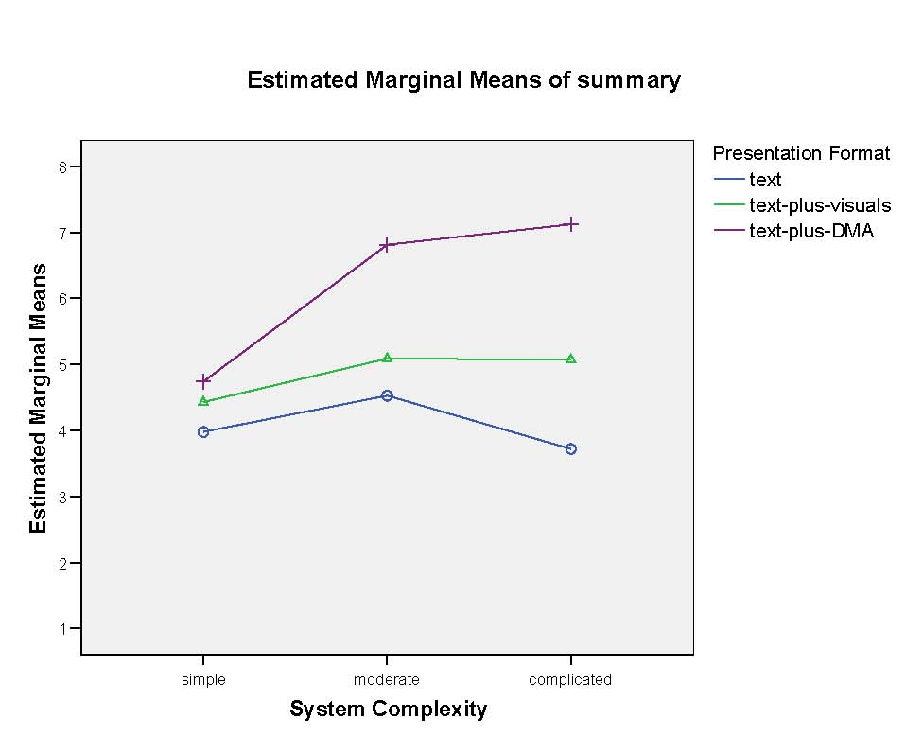

Figure 4: Effect of presentation format and system complexity on visual recall
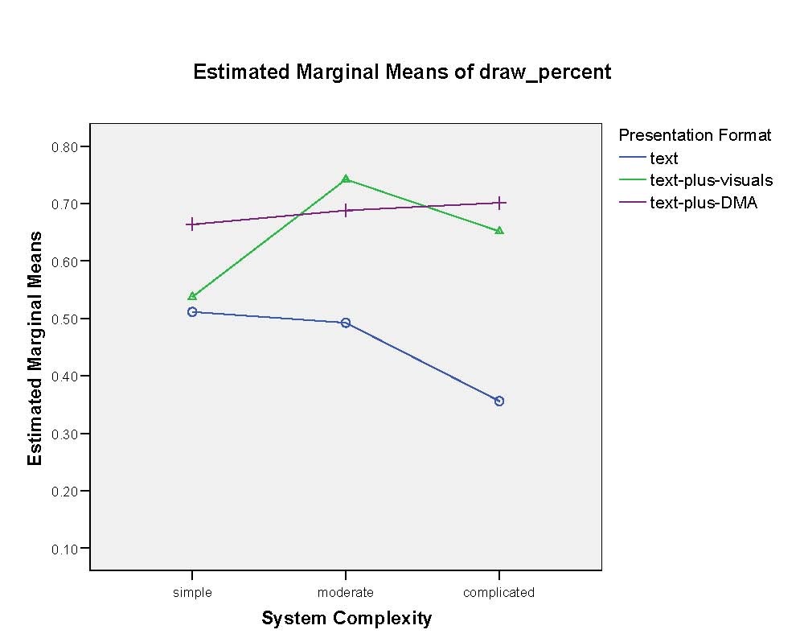

Figure 5: Effect of presentation format and system complexity on reasoning in the what-if scenarios

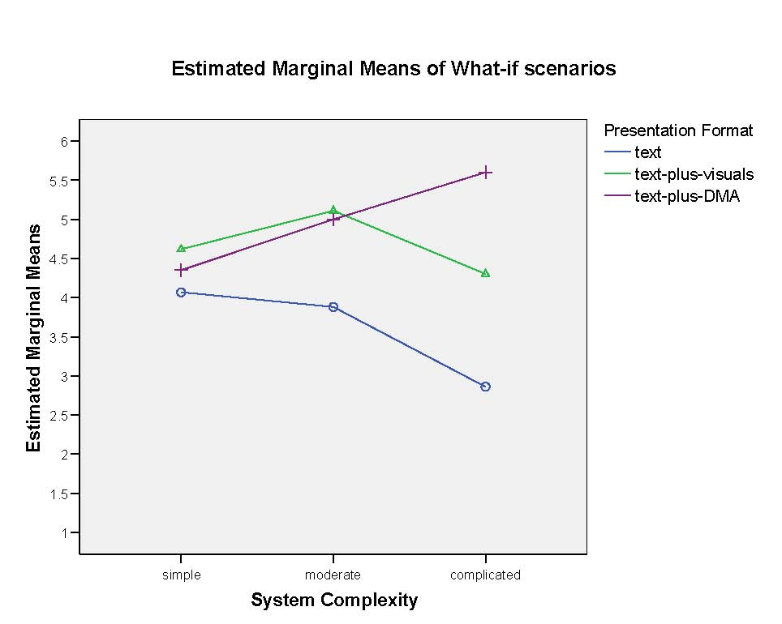

Figure 6: Effect of presentation format and system complexity on reasoning in “What’s wrong here?” scenarios
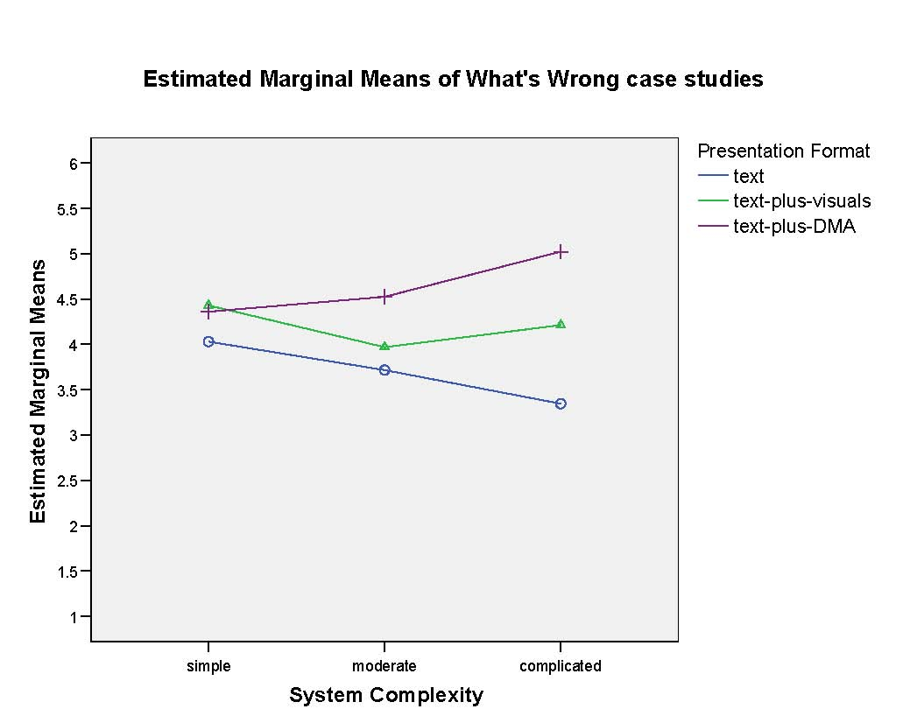

Figure 7: Effect of presentation format and system complexity on transfer performance

