Directions for resetting your Dreamweaver FTP accounts.

Server: tc-web.tc.columbia.edu
Host Directory: centers\odprograms
Your new login: tc\web_neugar
Your new password: ppod10

The following information is specifically addressing Dreamweaver users, but the information on the server name and your account applies to all FTP clients.

1. Open Dreamweaver and if the Site Window does not open automatically, bring it up by clicking on "Site->Site Files" in the top menu.

2. In the "Site" window, click on "Site->Define Sites" and in the next window, click on your site's name and then click "Edit..."

Or, if no site yet exists, click on “New…”

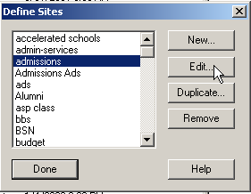

3. Set your local folder to a folder located on your computer’s hard drive. 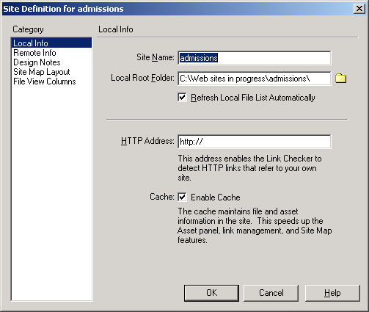

4. In the Site Definition window, select “Remote Info” from the Categories on the left and then set up the Login and Password with your new user account information.

Your login will be tc\web_neugar
Your account information is included at the top of this page.

